Image Repair Theory: Hexagon (Julia Dahl, M.D. based on the work of Benoit and others)

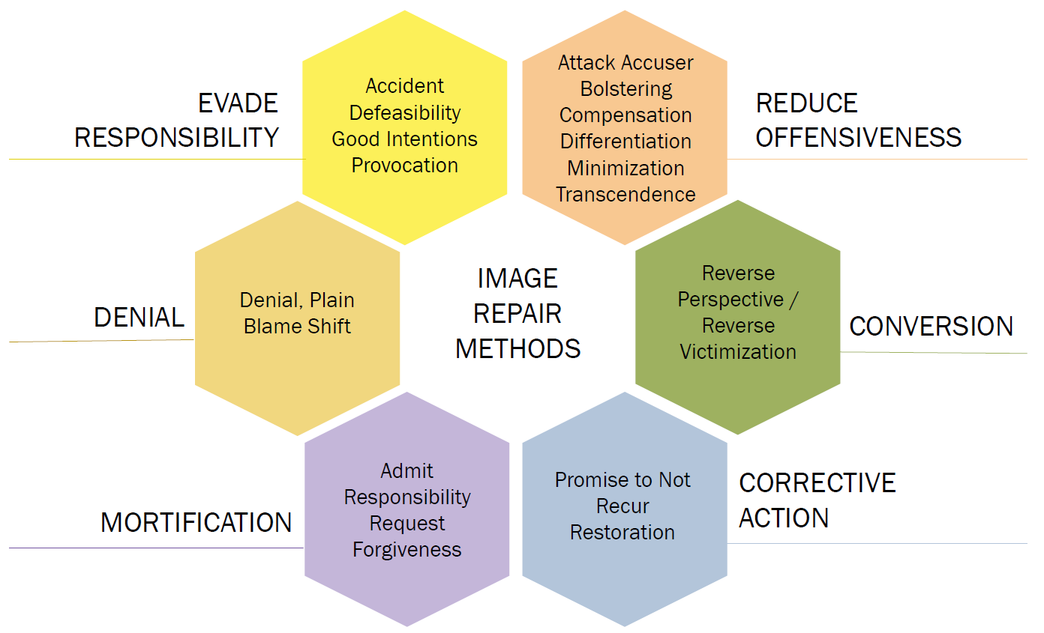
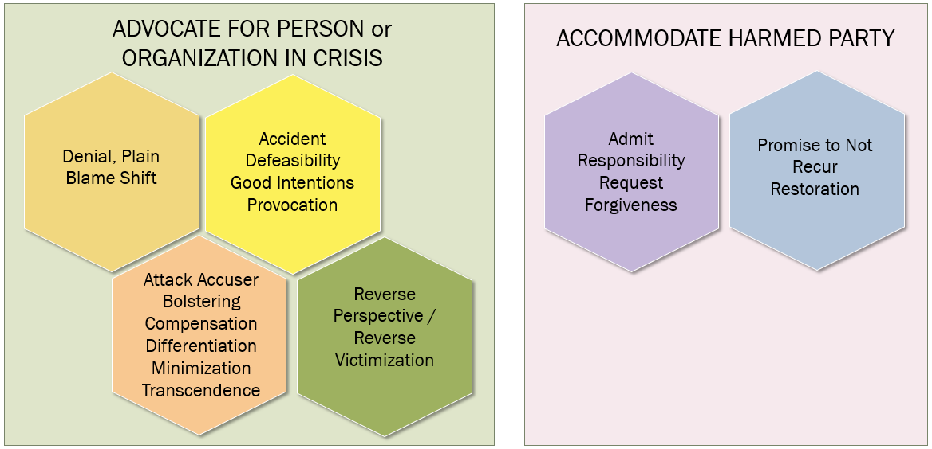
Summary of Image Repair Methods:
Category | Strategy | Description
Denial | Denial, plain | Person/Organization in crisis states that he/she did not perform the act.
 | Shift the blame | Person/Organization in crisis states that the act occurred; however, the act was performed by someone other than himself/herself.
Evasion of responsibility | Provocation | Person/Organization in crisis states or infers that he was responding to the act or action of someone other than himself.
 | Defeasibility | Person/Organization in crisis evades responsibility by alleging that the leader had no control over the attack; or no way to know it was immoral.
 | Accident | Person/Organization in crisis states that the act was unintentional
 | Good intentions | Person/Organization in crisis “meant well” when performing the act.
Reducing Offensiveness | Bolstering | Person/Organization in crisis states his/her or the organization’s good or positive traits
 | Minimization | Person/Organization in crisis contends that the act was not serious. This can include temporal distancing (it occurred long ago), statements that “it wasn’t that serious” or that accounts were “exaggerated/blown out of proportion,” or “there was no real harm done.”
 | Differentiation | Person/Organization in crisis contends the act was less offensive than others believe
 | Transcendence | Person/Organization in crisis contends that there are more important considerations that deserve focus
 | Attack accuser | Person/Organization in crisis reduces credibility of the accuser
 | Compensation | Person/Organization in crisis states he will reimburse victim or provide monetary or other settlement.
Conversion | Reverse Perspective / Reverse Victimization | Person/Organization in crisis combines two or elements of denial, bolstering, attacking the accuser and transcendence to simultaneously shift attention and sympathy away from the victim while focusing positive attention and sympathy toward himself or the organization.

Corrective action | Restoration | Person/Organization in crisis recognizes all aspects of action that created harm and states plan to restore victim to state prior to the act, if possible.
 | Promise to not recur | Person/Organization in crisis recognizes all aspects of action that caused harm and details plan/promise that action will not recur.
Mortification | Admit responsibility | Person/Organization in crisis recognizes all aspects of action that caused harm and admits responsibility for each action. This must be inclusive of all aspects of injury to victim and/or violation of law. Person/Organization in crisis must be willing to submit to application of consequences from law enforcement. If statute of limitations has expired, Person/Organization in crisis must be willing to admit responsibility according to current law; despite that consequences will have been avoided.
 | Request forgiveness | Person/Organization in crisis sincerely apologizes for all aspects of act that caused harm. Person/Organization in crisis does not offer conditional apologies (but,) or partial confessions. Person/Organization in crisis asks for forgiveness; however, respects victim’s right to forgive on their timetable. Reconciliation with the Person/Organization in crisis is not required as a function of offering request for forgiveness.

Note: Behavioral Traits and Personality Disorders are not synonymous terms. Dark Triad refers to personality traits. There is some overlap in the use of terminology that creates confusion. While all people are capable of displaying narcissistic, Machiavellian and anti-social traits – when these traits are disproportionate AND the person either is aware of the damaging trait and prefers to behave in this manner or is not aware of the trait and is unable recognize the damage that disproportionate expression of this trait results in – those people likely would meet diagnostic criteria for Narcissistic personality disorder (NPD) or Anti-social personality disorder (ASPD).
For additional information, see references, below.
Category | Strategy | Connections to Abusive Behavioral Traits (Narcissism, Machiavellianism and Psychopathy) and Personality Disorders
Denial | Denial, plain | NPD, ASPD high use of Dark Triad Traits:  Characteristic of this phenotype is to never be at fault for anything that they have done. If there is no proof of the act, the person will lie about whether or not it happened.  If there is proof of something, the person will admit only what is provable.  Denial has added benefit of creating cognitive dissonance within the victim/abused. The victim will doubt their instincts or their version of the truth because the person denying the event is so convincing in their lies and denial.
 | Shift the blame | Blame shift – projection of behavior onto victim or others. People with NPD, ASPD or high proportion dark triad traits are easily able to side step responsibility for an action by substituting another person to blame, whether someone who advised the action, someone who introduced the victim to the abuser or to the victim themselves. Shifting the blame is imperative to the person to retain (1) their elevated sense of self – being blameless, faultless and special; (2) to reduce the view of others in their own eyes – further supporting #1; (3) cause shame in the person who the blame is shifted to; (4) require the person to whom the blame is shifted to expend more emotional energy towards THEM – which is narcissistic ego fuel, among other reasons.

Category | Strategy | Connections to Abusive Behavioral Traits (Narcissism, Machiavellianism and Psychopathy) and Personality Disorders
Evasion of responsibility | Provocation | The person will frequently indicate that they did not initiate acts; but are responding to the acts of others in an effort to avoid responsibility or blame for acts that they committed.
 | Defeasibility | The person will often use “ignorance” or “I didn’t know” or “it just happened” excuse to evade responsibility. The person will state varying forms of having no control over the situation; or no way to know it was immoral.
 | Accident | The person will often claim an act was unintentional, “it just happened” or will use distancing, passive voice phrases about “it happening” or “what happened” to reinforce that it was accidental, and therefore they should not be held accountable. Predators do not do all things by accident. There is a careful selection process and grooming to create the environment in which abuse can occur.
 | Good intentions | The person will try to connect the act with that they “meant well” when performing the act. Predators have only one (1) intent and that is to have other people meet their needs. Experts at manipulations, they can appear to be serving others or doing something good in the midst of causing significant harm.

Category | Strategy | Connections to Abusive Behavioral Traits (Narcissism, Machiavellianism and Psychopathy) and Personality Disorders
Reducing Offensiveness | Bolstering | The person will consistently ask victims to reframe their experience of the person overall in terms of the good or positive traits. This is part of the idealize and devalue abuse cycle and trauma bonding with the victim.
 | Minimization | The person will contend that the act was not serious by using temporal distancing (a long time ago), comparison to more serious offenses (it wasn’t murder), name accomplices to distribute acts to other people (minimization through dilution – “I only drove the getaway car”)
 | Differentiation | The person will reframe or redefine what happened to contends the act was less offensive than others believe. “It only happened once, it wasn’t a pattern.” “You don’t know the whole story.”
 | Transcendence | The person will use transcendence to refocus attention on something other than the abuse or other negative action they performed. “Think of the children.” “Think of my wife.” “If this gets out, people will lose their faith in the church.” Transcendence is essential to employ “reverse victim” tactics. The focus has to somehow always be on how THEY were hurt or their supposed remorse, what backlash they are experiencing since the act was exposed, the other people who would be hurt if they had to face consequences of their actions. That compels people to be less offended by the initial act and focus on what’s happened since the exposure.
 | Attack accuser | Particularly while under attack, the person or their loyal aides will go on a “smear campaign” against anyone who they suspect will side with the victim and the victim themselves. The goal is to reduces credibility of the accuser by various attacks in order to reinforce their own believability and to cause the victim to be doubted and experience backlash from the people who support the abuser.  Common tactics include:  - Victim blaming: point to the victim’s responsibility (she should have known better),  - Victim character assassination with secrets entrusted: the person will disclose secrets that the victim told him (this is why they ask for secrets – to give the impression of trust and also to gain ammunition) that put the victim in an unfavorable light;  - Provocation: the person or aides will provoke victims to get an emotional reaction to make the victim look unstable.
 | Compensation | The person will state publicly that they are willing reimburse victim or provide monetary or other settlement. They are highly unlikely to actually make this payment. When compensation is made, it is generally in the form of initial grand gestures. The person will frequently mention the compensation when informing people who inquire about the crisis, pointing to either compensation being the reason the person exposed the crisis – or to bolster themselves.

Category | Strategy | Connections to Abusive Behavioral Traits (Narcissism, Machiavellianism and Psychopathy) and Personality Disorders
Corrective action | Restoration | People with NPD/ASPD and possibly those with high proportion of dark triad traits do not experience genuine empathy or act for the benefit of others (without some agenda for personal gain).  The person lacks emotional capacity to feel badly that their actions caused harm. They will frequently blame the victim “they should have known better than to trust me” or “it’s their fault that they got hurt.” Skilled people with NPD and dark triad traits can mimic emotions and pretend to display concern. In these instances, the persistent behavior – conduct that follows the statement of the emotion is a more reliable indicator.  The presence of genuine remorse, empathy and prioritizing the healing of the victim over preservation of the person’s positions argues against the possibility of NPD/ASPD.  A Person/Organization in crisis should demonstrate care for the victim that is genuinely interested in learning from the victim what the VICTIM believes will result in their restoration. A Person/Organization in crisis should be aware that reconciliation with an abuser is not a Biblical requirement and be focused on the victim’s safety and healing; no matter what the cost to the Person/Organization in crisis.
 | Promise to not recur | NPD/ASPD phenotypes are skilled at “future faking” and making serial promises that they never intend to keep. To determine if promises are valid or sincere, queries regarding specific plans for restoration, plans for current and future behavior must be addressed and monitored. High functioning NPD and ASPD become progressively more skilled at hiding heinous behavior and lying; rather than not having the event recur. If person who caused harm can articulate all aspects of action that caused harm and details plan/promise that action will not recur; this argues against NPD/ASPD. Actions that take place subsequently are the only means to determine the veracity of the promise.

Category | Strategy | Connections to Abusive Behavioral Traits (Narcissism, Machiavellianism and Psychopathy) and Personality Disorders
Mortification | Admit responsibility | People with NPD/ASPD and high proportion of dark triad trait expression have profound difficulty in admitting responsibility for any action that is perceived as wrong or caused harm. Even when stating a connection to wrong-doing, the person will nearly always use methods such as deflection, sharing the blame, claiming ignorance or “being the hero” in the midst of an accusation to avoid admitting outright responsibility for what has occurred. If a Person/Organization in crisis balks at admitting complete responsibility for a negative event, that is highly suspect for dark triad behavior.
 | Request forgiveness | People with NPD/ASPD and high proportion of dark triad trait expression are often skilled at offering what appear to be sincere apologies in the moment; however, rescinding the apology or quickly changing the topic in such a way that the victim or accuser must also apologize for some harm that the religious caused. When Person/Organization in crisis offers only conditional apologies (but,) or partial confessions, asks for forgiveness; however but demands victim’s forgiveness as being more important and demands reconciliation; signs point to DTPD.

